**INTERNSHIP PROJECT REPORT SUBMITTED BY**

**ECE-D BATCH NO: 01**

**PARISE HARICHANDANA (18481A04G4)**

**PARUPUDI GOPI VEERA MALLESWAR (18481A04G5)**

**PEDDIREDDY MADHUKAR BOBBY (18481A04G6)**

**PETETI VAMSI(18481A04G7)**

**PILLAMGOLLA AKHIL(18481A04G8)**



 **In association with**

**JUNE 2021**

**WILD ANIMAL DETECTION SYSTEM**

**AND**

**ALERTIN G SYSTEM FOR FOREST DEPARTMENT**

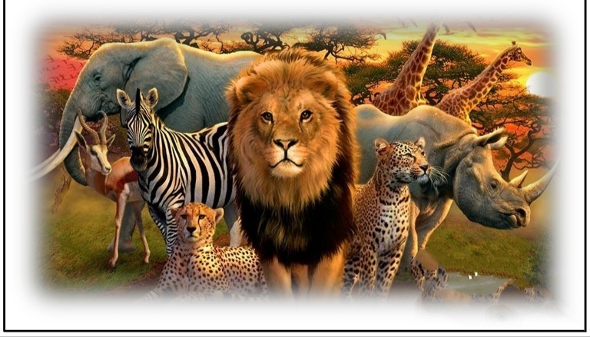

**TABLE OF CONTENTS:**

**1. INTRODUCTION**

1.1 Overview

    1.2 Purpose

**2. LITERATURE SURVEY**

**3. RELATED WORK**

3.1 Block diagram

**4. FLOWCHART**

**5. HARDWARE /SOFTWARE USAGE**

**6. EXPERIMENTAL INVESTIGATIONS**

**7. RESULT**

**8. NODE RED CONNECTIONS**

**9. ADVANTAGES & DISADVANTAGES**

**10. APPLICATIONS**

**11. CONCLUSION**

**12. FUTURE SCOPE**

**13. BIBLIOGRAPHY APPENDIX**

      A. Source code

      B. UI output Screenshot

**1.1 OVER VIEW:**

Wildlife entering populated areas has recently become common place. The space for wild animals is decreasing as humans are encroaching forests. It creates great loss to property and life when wild animals enter cities. We use latest advances in technology such as Internet of Things (IOT) to create an alert system of possible wildlife leaving the forest. We use low cost motion detectors and single board computer to achieve this. We relay information of such motion to a control center to take further actions. We also propose a deterrent such as making loud noise through speakers which can prevent wild animals from leaving the forest. The basic idea of IOT is to connect different sensors and establish communication and also provide services. In this article, we make use of several IOT devices at the periphery of natural reserve to create an alert system. This system can also be used to find out smugglers and other people illegally entering the forest.

* 1. **PURPOSE:**

Humans try to prevent wild animals from entering their area and agricultural land by passing

high voltage electricity in the fences across the forest edge. This is a dangerous solution

for both humans and wildlife. In order to avoid the conflict between humans and wild animals

and to prevent endangered species like wild elephants dying from accidents, we propose an

intelligent embedded solution using the latest technologies. Reduction in cost of single board

computers and improvements in battery technology, combined with continued miniaturization

of transmitter components, will likely reduce transmitter size further, while increasing

efficiency and extending either detection range or tag life made our system low cost. We are

using Raspberry Pi 2 for this project as it is a single board computer and low cost. It has a huge

user base and it operates on open source software. We are showing a proof of concept which

can be scaled and the cost further reduced by mass production and embedding chip with all the

modules integrated on a single chip.

|  |  |
| --- | --- |
|  | **2.LITERATURE SURVEY:**  Usage of sensor networks in monitoring, tracking and detection of different wildlife  species is a common practice that is carried on. For small animals and birds, RF tags are  used to track their motion using radio telemetry. This is a costly solution and these RF  tags have to be replaced after their life span. To overcome these limitations a new  technology is needed that enables new ways to monitor wildlife. A team of expert  researchers are working on the different aspects of such a new technology. They have also  reported on their research on a sensor- network-based tracking solution for bats. A  preliminary research on the real-world bird tracking system, and discussion how the  system's working process and also its mechanisms such as power saving techniques, data  storage, and communication indication, data transfer is done and mainly it is low cost  which is beneficial limitation of previous approach, tracking of wildlife using radio  collars was implemented. This approach also reduced implementation cost. Radio collar  was tied around animal’s neck which generated very high frequency. Researchers have to    physically go into the field and try to pin point using directional antenna. This approach is  time consuming. To improve on this approach an aircraft drone with radio on-board is  used which receives the signal and collar position of animal traced. A wireless sensor  network system is developed to monitor the migration patterns of Swamp Deer, known as  Wild CENSE. In this approach climatic and positional information of animal was  collected and sent to base station using peer to peer network. Radio transceivers are used  to transmit data to base station. From each peer node an external data flash memory is  used to record the collected data. The collected information would be sent to database  server via internet.  **33.RELATED WORK:**  I Incidents of wild animals entering cities and injuring peoples have become very common.  This is an example of man animal conflict arising out of wildlife straying into human areas.  We propose a sensor network system to create an alert system sensor network as shown in fig.1  Screenshot (14).png    FIG.1 The forest boundary with sensor towers tracking the animal near boundary  The sensor tower in the Fig 1 is present at the boundary of the forest to track movement of  wildlife ahumans near the boundary. The sensor tower is made up of Raspberry Pi 2 (RPi 2) and  other components.RPi 2 as it is single board computer with Linux operating system. RPi 2 has 40  GPIO pins which can be used to control and i get infomation from the sensors. It also has 4 USB  ports which can be used to connect web camera. It works with very low power which is needed for  our application. RPi 2 acts like a mini computer processing all the information and relaying that  information to the service center. We use PIR sensors for motion detection. An alternative can be to  use IR camera but for simplicity we use PIR sensors. The sensor tower also has GPRS/3G module  to connect to the control center. The boundaries of the forest have GPRS connectivity as they are  closer to the human population. This makes communication easier. If a motion is detected by the  PIR sensor, we take the picture of the region and send it to the control center. We also send a SMS  to the concerned official. If the control center needs to make a warning sign or noise, it can send a  signal to the concerned tower to make loud noise and scare the wildlife from crossing the forest  boundary. We know the location of each tower as it is fixed. If needed the officials can go the  location quickly and can take further measures. The block diagram of sensor tower/ Raspberry Pi  module is shown in Fig 2. Raspberry pi 2 is connected to a USB camera which takes the snaps  whenever motion is sensed and sends it to a web server using internet. The snaps taken can also be  used to monitor animal migration patterns and their social behavior. We use solar power at each  sensor tower as it may not be economical to have electric lines throughout the boundary of the  forest. The solar panel charges a battery and this provides the power to the sensor tower. Since the  power consumption is low, the system works on stored battery power even at night. We use Python  language for programming of Raspberry pi. Python language is a high level, general purpose coding  language. Most importantly it is simple to understand and easy to code. Any other coding language  compatible with raspberry pi can also be used. Open CV is installed on raspberry pi 2 for the  purpose of image detection.  **3.1 BLOCK DIAGRAM:**  Screenshot (17).png |
|  | **Jh**    FIG.2 The block diagram of sensor tower used for wild life tracking    **4. FLOWCHART :**  Screenshot (19).png |

|  |  |
| --- | --- |
|  | FIG.3 The flow of proposed system. Once the message have been sent the process  again repeats without human interaction.  **5. Hardware/Software designing :**  **Software Designing:**  The software used for smart parking system is:   1. Python 2. IOT Cloud Platform 3. IOT Communication Technologies 4. IOT Communication Protocols   **6. EXPERIMENTAL INVESTIGATION :**  The Internet of things (IoT) is a system of interrelated computing devices; mechanical and digital  machines provided with unique identifiers and the ability to transfer data over a network without  requiring human-to-human or human-to-computer interaction. The definition of the Internet of things  has evolved due to the convergence of multiple technologies, real-time analytics, machine learning,  commodity sensors, and embedded systems. For example, an IoT platform can continuously monitor  the location and vacancies of spaces in parking. This can only be possible with the I0T and its seamless  connectivity among devices. |
|  | **7.EXPERIMENTAL RESULTS:** |

|  |  |
| --- | --- |
|  |  |
|  |  |

**Node red output**

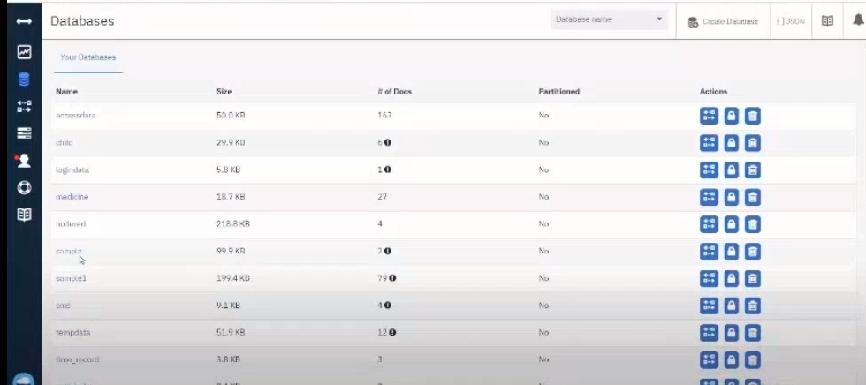

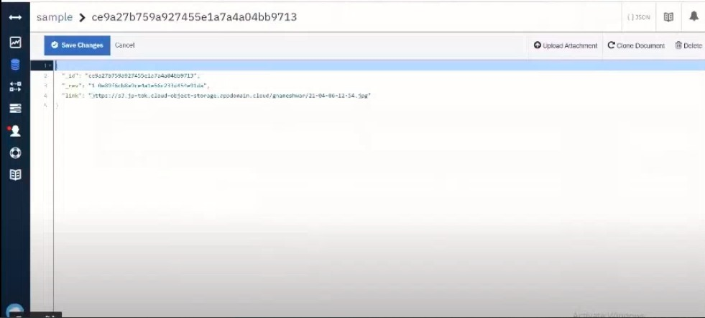

Code output

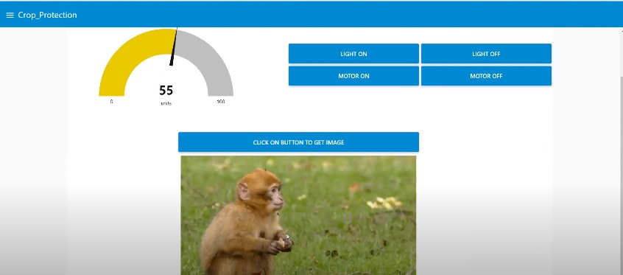

Web ui